**HAPPY PETS: PET ADOPTION PLATFORM**

**A MINI PROJECT REPORT**

***Submitted by***

**DEVIKA C (221801009) KEERTHIKA P(221801027)**

***in partial fulfillment for the award of the degree of***

**BACHELOR OF TECHNOLOGY IN ARTIFICIAL**

**INTELLIGENCE AND DATA SCIENCE**



**RAJALAKSHMI ENGINEERING COLLEGE**

**DEPARTMENT OF ARTIFICIAL INTELLIGENCE AND DATA SCIENCE**

**ANNA UNIVERSITY, CHENNAI**

**May 2025**

**ANNA UNIVERSITY, CHENNAI**

**BONAFIDE CERTIFICATE**

Certified that this Report titled “**HAPPY PETS: PET ADOPTION PLATFORM** ”is the bonafide work **DEVIKA C (221801009) , KEERTHIKA P (221801027)** who carried out the work under my supervision .

|  |  |
| --- | --- |
| **SIGNATURE** | **SIGNATURE** |
| **Dr. J. M. GNANASEKAR, M.E., Ph.D.,**  Professor and Head,  Department of Artificial Intelligence and  Data Science,  Rajalakshmi Engineering College,  Chennai – 602 105. | **RENUKA DEVI.S, M.E.,**  Professor and Head,  Department of Artificial Intelligence and Data Science,  Rajalakshmi Engineering College, Chennai – 602 105. |

Submitted for the project viva-voce examination held on______________________.

**INTERNAL EXAMINER EXTERNAL EXAMINER**

**ACKNOWLEDGEMENT**

Initially we thank the Almighty for being with us through every walk of our life and showering his blessings through the endeavor to put forth this report. Our sincere thanks to our Chairman **Mr. S. MEGANATHAN, B.E, F.I.E.**, our Vice Chairman **Mr. ABHAY SHANKAR MEGANATHAN, B.E., M.S.,** and our respected Chairperson Dr. **(Mrs.) THANGAM**

**MEGANATHAN, Ph.D.,** for providing us with the requisite infrastructure and sincere endeavoring in educating us in their premier institution.

Our sincere thanks to **Dr. S.N. MURUGESAN, M.E., Ph.D.,** our beloved Principal for his kind support and facilities provided to complete our work in time. We express our sincere thanks **to Dr. J. M. GNANASEKAR., M.E., Ph.D.,** Head of the Department, Professor and Head of the Department of Artificial Intelligence and Data Science for his guidance and encouragement throughout the project work. We are glad to express our sincere thanks to our supervisor **RENUKA DEVI.S., M.E.,** Head of the Department, Department of Artificial Intelligence and Data Science, Rajalakshmi Engineering College for his valuable guidance throughout the course of the project.

Finally we express our thanks for all teaching, non-teaching, faculty and our parents for helping us with the necessary guidance during the time of our project.

**ABSTRACT**

The Pet Adoption Management System is a web-based platform designed to streamline and digitize the process of pet adoption, donor contributions, and administrative control for animal shelters and rescue centers. The core objective of this system is to provide a centralized solution that simplifies the adoption of stray and shelter animals while fostering community engagement through seamless online donations. Built using modern web technologies such as PHP, MySQL, and Bootstrap, the system caters to two main user roles: general users (pet adopters and donors) and administrators. Users can browse available pets, view detailed profiles, submit adoption requests, and make financial contributions directly through the platform, all within a user-friendly and mobile-responsive interface. Meanwhile, administrators have access to a powerful backend dashboard that allows them to manage pets, monitor adoptions, approve requests, and analyze donation trends. The system is further enhanced with role-based authentication, data validation, and real-time updates to ensure security and performance. By bridging the gap between animal shelters and potential pet owners, the system not only reduces the administrative burden on shelter staff but also increases the chances of pet rehoming and boosts public participation in animal welfare. Overall, this project represents a socially impactful technological intervention aimed at improving animal adoption rates, increasing donations for pet care, and providing a structured, transparent, and scalable digital platform to support animal rescue missions.

**TABLE OF CONTENTS**

**CHAPTER NO. TITLE PAGE NO.**

**ABSTRACT**

* 1. **INTRODUCTION**
  2. GENERAL 1
  3. NEED FOR THE STUDY 2
  4. OBJECTIVE OF THE STUDY 2
  5. OVERVIEW 5

**2. REVIEW OF LITERATURE**

* 1. INTRODUCTION 7
  2. FRAMEWORK OF LCA 8

1. **SYSTEM OVERVIEW** 
   1. EXISTING SYSTEM 11
   2. PROPOSED SYSTEM 13
   3. FEASIBILITY STUDY 16
2. **SYSTEM REQUIREMENTS**

4.1 HARDWARE REQUIREMENTS 21

4.2 SOFTWARE REQUIREMENTS 22

**5. SYSTEM DESIGN**

* 1. SYSTEM ARCHITECTURE 24
  2. MODULE DESCRIPTION 25

5.2.1 USER MANAGEMENT MODULE26

* + 1. PET MANAGEMENT MODULE 28
    2. ADOPTION MODULE 32
    3. DONATION MODULE 33

1. **RESULT AND DISCUSSION**  35
2. **CONCLUSION**

7.1 CONCLUSION 36

7.2 FUTURE ENHANCEMENT 36

### APPENDIX

A1.1 SAMPLE CODE 37

A1.2 SCREENSHORTS 47

REFERENCES 49

**LIST OF FIGURES**

**Figure No Figure Name Page No**

1. System Architecture 24

2. Home page 1 47

3. Home page2 47

4. Adoption Page 48

5. Donation page 48

**CHAPTER -I**

**INTRODUCTION**

**1.1 GENERAL**

The Pet Adoption Platform is a web-based application developed to simplify and digitize the process of pet adoption. In recent years, the number of stray and abandoned animals has seen a significant rise, creating a need for effective adoption mechanisms. Traditional methods often involve manual paperwork, limited visibility for adoptable pets, and lack of centralized data management, which delays the process and reduces the chances of successful adoptions. This project addresses these issues by leveraging modern web technologies to build a dynamic and interactive platform.

The system is divided into three core layers: the client side, the server side, and the database. The **client side** is designed using HTML, CSS, Bootstrap, and JavaScript to provide an intuitive and responsive interface. This allows users to easily browse pet profiles, submit adoption applications, and make donations. The **server side**, built with PHP, handles critical functions such as form validation and session management, ensuring secure and reliable interactions between users and the platform. The **database**, powered by MySQL, stores and organizes information including user details, pet records, adoption data, and donation history.

Through this platform, users can create accounts, view available pets categorized by breed and species, and adopt pets based on availability and eligibility. The application also includes an admin interface that allows shelter staff or authorized personnel to manage pet listings, review adoption requests, and monitor user activity. Moreover, a donation module is incorporated to allow financial support from users who may not be able to adopt but still want to contribute to animal welfare.

Overall, the Pet Adoption Platform provides an effective and scalable solution to help shelters increase pet adoptions, raise funds, and manage their operations more efficiently. It demonstrates how technology can be used to bring together communities and create meaningful social impact.

**1.2 NEED FOR THE STUDY**

In today’s world, animal shelters and rescue organizations face numerous challenges in connecting homeless pets with potential adopters. Despite the increasing use of digital technologies in many sectors, pet adoption processes still remain largely manual and fragmented. This creates barriers such as limited visibility of available pets, slow adoption processing, and poor data management. Moreover, many people who are willing to adopt pets are often unaware of nearby shelters or the procedures involved. These challenges highlight the urgent need for a centralized and user-friendly digital platform dedicated to pet adoption.

Another significant concern is the rising population of stray and abandoned animals. Due to urbanization and shifting lifestyles, many pets are left homeless, increasing the burden on shelters. Most shelters are underfunded and lack proper tools to manage records or track donations and adoptions. Without an efficient system in place, many adoptable pets remain in shelters for extended periods, which affects their health and chances of finding a home. A structured platform can help streamline the workflow, from listing pets to processing adoptions and receiving donations.

The study and development of a Pet Adoption Platform is essential not only for operational efficiency but also for improving public awareness and engagement in animal welfare. With features like real-time pet listings, donation tracking, user management, and admin control, the platform can significantly enhance the adoption experience for users while empowering shelters to perform better. The project also aligns with the broader objective of encouraging responsible pet ownership and reducing the number of animals without homes.

By addressing these pressing issues through technology, the study aims to bridge the gap between pet seekers and shelters, enabling faster adoptions, better care for animals, and greater transparency in shelter operations. The Pet Adoption Platform, therefore, is not just a technical solution—it is a social initiative towards a more compassionate society.

**1.3 OBJECTIVES OF THE STUDY**

The primary objective of the Pet Adoption Platform project is to leverage technology to create a centralized, digital solution that simplifies the process of pet adoption, improves shelter management, and encourages community involvement in animal welfare. The platform is intended to solve real-world issues such as inefficient pet listing processes, lack of communication between adopters and shelters, poor record-keeping, and minimal visibility of adoptable pets. By implementing a user-friendly web-based system, this project aims to connect individuals seeking to adopt with the pets in need of a home, while also offering functionalities like donation tracking and administrative controls.

One of the key objectives is to **streamline the pet adoption process** through an intuitive user interface. Traditionally, potential adopters have to visit shelters physically, browse limited listings, or rely on outdated websites. This project seeks to eliminate those barriers by creating an online platform where adopters can browse a wide range of available pets categorized by species, breed, and age. The system provides comprehensive profiles for each pet, including images, characteristics, health status, and shelter location. This digital transformation not only saves time and effort for adopters but also enhances the pets’ visibility, significantly increasing their chances of finding a permanent home.

Another crucial objective is to **facilitate efficient shelter operations** through the administrator dashboard. Shelters often lack the tools and manpower to maintain detailed records, track adoptions, or manage donations. The platform addresses these issues by giving administrators the ability to add, edit, and remove pet listings, monitor adoption status, and view detailed logs of donations and user interactions. This functionality greatly reduces the administrative burden on shelter staff, allowing them to focus on the care and rehabilitation of animals. The platform also provides real-time updates to prevent duplicate adoptions and maintain the accuracy of data across the system.

An equally important goal of the project is to **encourage financial support through a donation module**. Not all individuals are in a position to adopt a pet, but many are willing to contribute to animal welfare causes. The donation module allows users to make monetary contributions securely, add personalized messages, and receive acknowledgments. All donations are recorded and linked to user profiles, making it easier for shelters to maintain transparency and build trust with their contributors. This feature not only improves funding for shelters but also strengthens community engagement in animal rescue efforts.

A significant technical objective is to **implement secure and scalable architecture** for long-term use. The platform uses a combination of client-side (HTML, CSS, JavaScript, Bootstrap) and server-side technologies (PHP) along with MySQL for data storage. Security practices like password hashing and input validation are implemented to protect user data and prevent unauthorized access. The modular structure of the codebase ensures that new features, such as volunteer sign-ups or event announcements, can be added in the future without disrupting existing functionalities. This scalability ensures that the platform can grow along with the needs of shelters and users.

From an academic and learning perspective, the project also serves the objective of **enhancing the developer’s understanding of full-stack web development**. This includes mastering frontend design, backend scripting, database design, form handling, and session management. Through the development of this platform, the student gains hands-on experience in real-world software development, requirement analysis, data modeling, and user testing. It also introduces essential software engineering principles such as modularity, reusability, and user-centric design.

Furthermore, the project aspires to **promote social responsibility and awareness**. It acts as a tool to sensitize the public about the increasing number of stray animals and the responsibilities of pet ownership. By providing educational content on the platform and making the adoption process more accessible, the project fosters a culture of compassion and informed decision-making among the public. Users are guided through the process of adoption, the responsibilities involved, and how they can continue to support animal shelters even after adoption.

In conclusion, the objectives of the Pet Adoption Platform are multifaceted, addressing both technical and social dimensions. Technically, it focuses on providing a robust, secure, and easy-to-use platform for managing pet adoption and donations. Socially, it strives to connect more people with animals in need, support shelter operations, and raise awareness about animal welfare. The successful implementation of this platform not only solves current inefficiencies in the adoption process but also serves as a stepping stone toward a more humane and digitally empowered society. It reflects how technology, when used thoughtfully, can significantly impact the lives of both humans and animals alike.

**1.4 OVERVIEW OF THE PROJECT**

The Pet Adoption Platform is a web-based application developed to simplify and systematize the process of adopting pets from animal shelters and rescue organizations. The primary goal of the project is to create a centralized digital space where potential adopters can easily connect with available pets, and shelter administrators can manage pet listings and adoption requests more efficiently. With the growing number of stray and abandoned animals, and the lack of digital adoption systems in many regions, this platform serves a critical need in animal welfare and community engagement. It also integrates a donation module, enabling compassionate individuals to contribute financially to shelters, even if they are not in a position to adopt a pet themselves.

The platform consists of three essential components—client side, server side, and database. The client side represents the user interface, designed using HTML, CSS, JavaScript, and Bootstrap. It offers an intuitive and visually pleasing experience for users, featuring pages such as the Home page, About Us, Contact, Adoption, Donation, and Admin login. The interface is responsive, ensuring that users can access the platform from a variety of devices, including desktops, tablets, and mobile phones. Each pet profile includes detailed information such as name, breed, age, species, and adoption status, allowing users to make informed decisions. The adoption page lets users browse available pets and initiate an adoption request through a simple and guided form submission process.

The server side, developed using PHP, handles key functionalities like user authentication, form processing, session management, and interaction with the backend database. It acts as the logic layer of the platform, ensuring that the data submitted by users is validated, securely transmitted, and stored. For example, when a user submits an adoption or donation form, the PHP scripts validate the data, initiate a session if the user is logged in, and then update the respective database tables. It also ensures that adoption status is updated in real time to prevent double adoption of the same pet.

At the heart of the platform is the MySQL database, which manages structured data for all users, pets, donations, and adoptions. Several key tables are used to store this information in a relational format. The **user table** stores information such as user ID, name, email, and encrypted passwords. The **pet table** holds data like pet ID, name, breed, species, age, description, and adoption status. The **donation table** logs each donation made, along with the user ID, amount, and any accompanying message. The **adoption table** records each successful adoption, linking the user ID with the adopted pet ID and timestamp. These tables are interlinked using primary and foreign keys, ensuring referential integrity and consistency across operations.

The platform also includes an admin module, accessible only through a secure login. The admin dashboard enables shelter staff or authorized personnel to manage all backend operations. This includes adding new pet profiles, editing or removing existing listings, reviewing adoption requests, and monitoring donation activity. The admin interface simplifies daily operations for shelters, replacing paper records with a structured and digital solution. Additionally, it enhances transparency and accountability in shelter activities, allowing them to track every action performed by users or staff.

From a user experience standpoint, the platform ensures a seamless journey from discovering a pet to completing an adoption request. It also respects user privacy and data security, with password encryption and validation processes in place. The donation module allows users to support animal welfare without necessarily adopting a pet. This is particularly important as many individuals care about animals but may lack the time, space, or resources to bring one home. Donations are logged securely and are visible to the admin for accountability.

In summary, the Pet Adoption Platform is a modern, scalable, and socially impactful web application that leverages digital technologies to enhance the pet adoption experience. It benefits both adopters and shelters by making the process transparent, efficient, and user-friendly. By bringing all stakeholders together on a single platform, the project contributes to increasing pet adoption rates, reducing the shelter population, and improving the overall welfare of animals in need. Through thoughtful design, technical reliability, and social relevance, the platform stands as a powerful tool in the mission to find every pet a loving home.

**CHAPTER II**

**REVIEW OF LITERATURE**

**2.1 INTRODUCTION**

The concept of pet adoption has evolved significantly with the integration of technology into animal welfare services. Traditionally, adopting a pet involved physically visiting animal shelters, going through manual procedures, and often dealing with limited information about the animals available. This approach was not only time-consuming but also resulted in lower visibility of pets and limited adoption success. With the emergence of digital solutions, there has been a noticeable shift in how shelters interact with the public and how potential pet owners search for and adopt pets. The objective of this literature review is to explore how existing research and systems have contributed to this transition, highlighting the technological trends, features, and functionalities that have enhanced the pet adoption process.

The growing availability of the internet and smartphones has made it possible for animal shelters to list pets online, receive adoption applications, and manage donations more effectively. Several platforms such as Petfinder, Adopt-a-Pet, and local shelter websites have been developed to bridge the gap between shelter animals and potential adopters. These platforms demonstrate the impact that user-centered design, search functionality, and reliable data management can have on adoption rates and overall shelter efficiency. By reviewing the successes and limitations of these systems, developers and researchers gain insights into how to build better, more efficient platforms. These insights serve as a foundation for the development of the Pet Adoption Platform, ensuring that the system is built on tried-and-tested practices while addressing gaps found in existing solutions.

From a research perspective, it is also important to examine studies on user behavior, system architecture, user interface design, and the psychological impact of digital adoption campaigns. Research indicates that users are more likely to adopt pets when they can view comprehensive profiles that include photos, breed details, age, behavior information, and health status. Literature also shows that integrating secure and simple user interfaces encourages users to engage more frequently with digital platforms. These findings support the inclusion of features such as detailed pet listings, secure login and registration, and administrator dashboards in this project.

Moreover, studies have found that pet adoption platforms not only benefit individuals looking for pets but also significantly help animal shelters with resource management. Manual tracking of adoptions, donations, and available animals is often prone to errors and inefficiencies. Literature on shelter management systems highlights the importance of digital tools in reducing administrative overhead, maintaining real-time inventory, and keeping accurate records of both animals and users. This review draws attention to the need for integrated admin panels and secure backend systems in adoption platforms—features that are addressed in the current project.

Another important dimension to consider in the review of literature is the role of **community engagement and donations** in supporting shelters. Research studies emphasize that not all individuals are in a position to adopt a pet, but many are willing to support shelters through financial donations or volunteer work. Digital donation modules integrated into adoption platforms can significantly improve fundraising and operational sustainability for animal shelters. These systems, when developed with transparency and user tracking, increase trust among contributors. This is another area where the Pet Adoption Platform aims to bring improvements by allowing users to make donations, leave messages, and receive confirmations for their contributions.

In conclusion, the introduction to the literature review sets the stage for an in-depth analysis of how existing platforms, tools, and research findings influence the design and development of the current Pet Adoption Platform. It also emphasizes the need for combining technical proficiency with user-centered design and social responsibility. The aim of this review is not only to highlight what has already been accomplished but also to draw lessons that can be applied to enhance the usability, scalability, and effectiveness of future adoption systems. Through this, the project aspires to offer a solution that addresses real-world challenges while encouraging compassion, awareness, and community participation in pet adoption efforts.

**2.2 FRAMEWORK OF LCA (Life Cycle Assessment)**

Life Cycle Assessment (LCA) is a structured methodology used to evaluate the environmental, social, and economic impact of a product, service, or system throughout its entire life cycle—from initial conception to end-of-life. Although LCA is traditionally applied to physical products and industrial processes, the same framework can be adapted to evaluate the life cycle and impact of digital platforms such as a **Pet Adoption Platform**. The LCA framework helps developers, stakeholders, and users understand the broader implications of the system they are designing and using. In the context of the Pet Adoption Platform, the life cycle includes phases like **planning, design, development, deployment, usage, maintenance, and evolution**.

**1. Goal and Scope Definition**

The first phase of the LCA framework involves defining the purpose of the assessment and setting boundaries. For this platform, the goal is to create a sustainable, user-friendly digital system that connects animal shelters with potential pet adopters. The scope includes the system’s design architecture, database structure, user interface, hosting infrastructure, and interaction with end-users such as shelter staff, adopters, and donors. This phase helps in clearly identifying what components will be analyzed in terms of performance, sustainability, and impact.

**2. Inventory Analysis (LCI)**

This phase involves collecting data on all inputs and outputs involved in each stage of the system's life cycle. In the context of the Pet Adoption Platform, this includes:

* **Hardware Resources**: Servers, hosting systems, and power consumption of data centers.
* **Software Tools**: Development environments like VS Code, XAMPP, PHP, MySQL, and frontend frameworks like Bootstrap.
* **Human Resources**: Time and effort invested by developers, testers, administrators, and users.
* **Data Resources**: Pet profiles, adoption requests, user registrations, and donation transactions.

By tracking these inputs and outputs, we understand the energy and resource usage throughout the development and operation of the system.

**3. Impact Assessment (LCIA)**

This stage evaluates the potential environmental and social impacts identified during the inventory analysis. Although a digital platform does not produce physical waste, it still consumes energy and contributes to carbon emissions through server use. In addition, improper data handling or non-transparent donation systems can result in a loss of trust or even ethical issues. The Pet Adoption Platform, by being built with lightweight code, optimized queries, and secure hosting, attempts to minimize its environmental and ethical footprint. Also, the system’s donation transparency and real-time updates aim to build public trust, encouraging continued use and support.

**4. Interpretation**

The final phase of the LCA framework involves evaluating the findings from previous phases to make informed decisions. For this project, it involves interpreting results to identify which components consume the most resources or introduce potential inefficiencies. For example, optimizing image sizes in pet profiles can reduce server load and improve performance. Ensuring backend scalability can reduce the need for frequent redevelopment. These interpretations help in improving system sustainability, reducing digital waste, and enhancing user satisfaction.

**Adaptation of LCA to Digital Platforms**

While LCA is often associated with tangible products, the adaptation of this framework to digital services like the Pet Adoption Platform provides a modern lens for responsible development. It ensures that the system is not only functional but also socially and environmentally conscious. Applying LCA also encourages modular design, efficient code reuse, cloud-based resource sharing, and ethical data management—principles that align with the goals of responsible software engineering.

**CHAPTER III**

**SYSTEM OVERVIEW**

**3.1 EXISTING SYSTEM**

The existing systems for managing pet adoption are primarily traditional and rely on manual methods, which result in inefficiencies and operational bottlenecks. Below is a detailed analysis of the existing system and its limitations across various dimensions:

**1. Manual and Time-Intensive Processes**

* Pet adoption today is often managed through manual workflows that require adopters to visit pet shelters physically. These visits are necessary to:
  + Obtain details about the pets available for adoption.
  + Submit paperwork and other required documentation.
  + Complete the adoption process, which can involve waiting periods and repetitive steps.
* Due to the lack of automation, the manual process is time-consuming and resource-intensive. Shelter staff spend significant time performing repetitive tasks, such as verifying documents and updating records.
* **Example:** A potential adopter may need to visit multiple shelters or contact them individually via phone or email to find a pet matching their preferences (e.g., breed, age, size). This can discourage adoption due to the effort involved.

**2. Fragmented and Decentralized Information**

* Information about adoptable pets is scattered across various platforms, such as:
  + Shelter-specific websites with limited visibility.
  + Social media channels with inconsistent updates.
  + Physical advertisements or word-of-mouth communication.
* This lack of centralized information creates hurdles for adopters, who cannot explore all available options in a single platform. Consequently, many pets remain unadopted simply due to visibility issues.
* **Example:** An adopter may find limited details on a pet's health, vaccination status, or behavioral traits on a shelter's website, requiring further communication to gain clarity.

**3. Limited Engagement and Accessibility**

* Communication between pet shelters and potential adopters or donors is largely restricted to conventional methods, such as phone calls and emails, which are slow and inefficient.
* There are no interactive or real-time platforms where adopters can:
  + Browse detailed profiles of pets (with images, videos, and health information).
  + Track the status of their adoption requests.
  + Provide feedback or connect with shelter staff seamlessly.
* Moreover, adopters often lack accessibility to detailed pet history, which is essential for making informed decisions.
* **Example:** A family interested in adopting a pet might struggle to confirm if a specific dog has been vaccinated, spayed/neutered, or is suitable for children.

**4. Inefficient Donation Systems**

* Pet shelters heavily rely on donations to sustain their operations, but existing donation systems are underdeveloped. Donations are often managed through:
  + Offline methods (e.g., cash or checks).
  + Basic online methods with limited tracking or acknowledgment for donors.
* Many potential donors hesitate to contribute because of a lack of transparency in how their funds are used. Donors are unable to see the impact of their contributions, which reduces trust and engagement.
* **Example:** A donor might be reluctant to support a shelter if there is no assurance that the money will directly benefit the animals.

**Impacts of the Existing System**

The limitations of the existing system have a cascading impact on all stakeholders involved:

**a. Pet Shelters:**

* Operational inefficiencies caused by reliance on manual processes.
* Inability to attract a wider audience for adoption or donations due to lack of digital presence.
* Challenges in maintaining transparency, which affects donor trust and engagement.

**b. Adopters:**

* Frustration caused by the effort required to gather information or complete adoption procedures.
* Missed opportunities to adopt pets due to poor visibility of available options.
* Inability to make informed decisions due to limited access to detailed pet information.

**c. Donors:**

* Reduced willingness to contribute due to lack of acknowledgment, transparency, and clear impact reporting.
* Inefficiencies in the donation process (e.g., absence of online payment systems) that discourage potential supporters.

**3.2 PROPOSED SYSTEM**

To address the inefficiencies and limitations of the existing system, a centralized, digital platform for pet adoption is proposed. This platform will streamline operations, enhance user engagement, and ensure transparency in donations and record management. Below is an in-depth explanation of the features and benefits of the proposed system:

**1. Centralized Platform for Pet Adoption**

* The proposed system will serve as a unified platform for managing all pet adoption-related activities, ensuring that shelters, adopters, and donors can interact seamlessly.
* Key features:
  + **Comprehensive Pet Profiles:** The platform will provide detailed profiles for each pet, including:
    - Name, age, breed, and species.
    - Vaccination status, medical history, and behavioral traits.
    - Images and videos to give adopters a better understanding of the pet.
  + **Advanced Search and Filtering:** Users can search for pets based on specific criteria such as breed, age, size, and adoption status.
  + **Real-Time Availability:** The platform will display the current status of each pet (e.g., available, reserved, adopted).

**Benefits:**

* Adopters can easily explore and select pets based on their preferences.
* Shelters can manage pet profiles efficiently and ensure they are always up-to-date.

**2. User-Friendly Interface**

* The system will feature an intuitive and responsive user interface that works seamlessly across devices, including desktops, tablets, and smartphones.
* **Design Elements:**
  + **Navigation:** Clear menus and sections for exploring pets, managing user profiles, and making donations.
  + **Interactive Features:** Adopters can save their favorite pets, share profiles on social media, and receive recommendations.
  + **Mobile Accessibility:** The platform will include a mobile-friendly design or dedicated app for convenient access.

**Benefits:**

* Enhances user satisfaction and engagement.
* Ensures accessibility for users on various devices.

**3. Efficient Donation Management**

* The platform will include a dedicated module for managing donations, making it easier for shelters to receive and track funds.
* Key features:
  + **Secure Online Payments:** Donors can contribute using multiple payment methods, such as credit/debit cards, bank transfers, or digital wallets.
  + **Impact Reporting:** Donors will receive updates on how their contributions are being used, such as for medical treatments, shelter maintenance, or food supplies.
  + **Acknowledgment and Receipts:** Automated emails and receipts will acknowledge every donation, enhancing donor trust.

**Benefits:**

* Simplifies the donation process and improves transparency.
* Encourages more users to support shelters through recurring or one-time contributions.

**4. Streamlined Adoption Process**

* The platform will digitize and automate the adoption workflow, reducing manual efforts and delays.
* **Features:**
  + **Online Applications:** Potential adopters can submit adoption requests directly through the platform.
  + **Application Tracking:** Users can track the status of their applications in real-time (e.g., pending, under review, approved).
  + **Digital Documentation:** The platform will support the upload and management of necessary documents, such as ID proofs and agreements.

**Benefits:**

* Reduces paperwork and processing time for shelters.
* Provides transparency and convenience for adopters.

**5. Robust Record Management**

* The platform will centralize all shelter records, ensuring data accuracy and easy access.
* **Key Components:**
  + **User Management:** Maintain detailed profiles of adopters and donors, including contact information, adoption history, and donation records.
  + **Pet Management:** Track the status of each pet, including adoption history and medical records.
  + **Analytics and Reporting:** Generate reports on adoption trends, donor contributions, and shelter operations.

**Benefits:**

* Facilitates better decision-making through data-driven insights.
* Ensures efficient and error-free record management.

**3.3 FEASIBILITY STUDY**

A feasibility study is conducted to evaluate the viability of the proposed pet adoption platform, focusing on its technical, operational, and economic dimensions. This section outlines the analysis of each feasibility type to ensure that the project is practical and can be implemented successfully.

**1. Technical Feasibility**

Technical feasibility assesses whether the proposed system can be developed using the available technology and tools.

**1.1 Technology Requirements**

* The proposed platform will use the following technologies:
  + **Frontend Development:** HTML, CSS, JavaScript, and Bootstrap for building an intuitive and responsive user interface.
  + **Backend Development:** PHP for managing server-side logic, including form validation and session management.
  + **Database Management:** MySQL for storing and managing data such as user details, pet profiles, adoption records, and donation logs.

**1.2 Scalability and Security**

* The system is designed to handle a growing number of users, pets, and transactions without performance degradation.
* Security measures such as data encryption, user authentication, and role-based access control will be implemented to ensure data safety.

**1.3 Technical Expertise**

* The tools and technologies required are widely available and well-documented.
* Developers with experience in PHP and MySQL can easily implement the system.

**1.4 Risk Analysis**

* Potential risks, such as server downtime or security breaches, can be mitigated by:
  + Using cloud-based hosting services for reliability.
  + Implementing robust cybersecurity measures.
  + Regularly updating software and performing system maintenance.

**2. Operational Feasibility**

Operational feasibility evaluates how well the proposed system aligns with the goals and needs of the stakeholders.

**2.1 User-Friendly Features**

* The platform is designed to be intuitive and accessible, ensuring that users (adopters, donors, and shelter staff) can easily navigate and perform their tasks.
* Features like pet search filters, donation management, and real-time adoption tracking enhance user engagement.

**2.2 Stakeholder Alignment**

* **Shelters:** Gain a streamlined platform for managing pets, user interactions, and donations.
* **Adopters:** Benefit from a convenient way to explore available pets and track adoption processes.
* **Donors:** Receive transparency and acknowledgment, increasing trust and motivation to contribute.

**2.3 Operational Challenges**

* Ensuring user adoption of the new system might require training for shelter staff and promoting the platform to adopters and donors.
* Initial data entry (e.g., creating pet profiles) may be time-intensive, but this is a one-time effort.

**2.4 Accessibility**

* The platform is designed to be mobile-responsive, allowing users to access it from any device.
* Features like multi-language support can be added in the future to cater to a broader audience.

**3. Economic Feasibility**

Economic feasibility evaluates the cost-effectiveness of the project and its potential for long-term sustainability.

**3.1 Cost Estimation**

* **Development Costs:**
  + Initial setup costs include purchasing a hosting plan, domain registration, and development resources.
  + Hiring a team of developers and designers (if outsourced) may incur additional costs.
* **Operational Costs:**
  + Ongoing costs include server maintenance, periodic software updates, and customer support.
* **Marketing Costs:**
  + Promoting the platform to potential users through social media, online advertisements, and partnerships with shelters.

**3.2 Revenue Streams**

* **Adoption Fees:** Shelters can collect nominal fees for each adoption processed through the platform.
* **Donations:** A transparent system may encourage higher contributions from donors.
* **Sponsorships and Advertisements:** The platform can feature sponsored posts or ads from pet-related businesses (e.g., pet food companies, veterinary clinics).

**3.3 Cost-Benefit Analysis**

* The benefits of the platform, such as improved efficiency, increased adoption rates, and higher donations, outweigh the initial and operational costs.
* The platform’s ability to streamline shelter operations reduces labor costs and operational inefficiencies.

**3.4 Return on Investment (ROI)**

* Increased adoption rates lead to fewer unadopted pets in shelters, reducing shelter maintenance costs.
* Enhanced donor engagement can secure recurring contributions, improving financial sustainability.

**4. Schedule Feasibility**

Schedule feasibility assesses whether the proposed system can be developed and implemented within the desired timeline.

**4.1 Project Timeline**

* The development process is expected to take approximately 4–6 months, divided into the following phases:
  + **Phase 1:** Requirement gathering and system design (1 month).
  + **Phase 2:** Frontend and backend development (3 months).
  + **Phase 3:** Testing and debugging (1 month).
  + **Phase 4:** Deployment and training (1 month).

**4.2 Resource Allocation**

* A team of 4–6 developers, including frontend and backend specialists, will be sufficient to complete the project on schedule.

**4.3 Risk Management**

* Potential delays in development can be mitigated by:
  + Setting clear milestones and deliverables for each phase.
  + Allocating buffer time to account for unforeseen challenges.

**CHAPTER – IV**

**SYSTEM REQUIREMENTS**

**4.1 HARDWARE REQUIREMENT**

To ensure smooth development, deployment, and use of the Pet Adoption Management System, the following hardware components are recommended. These requirements vary slightly depending on whether the system is being used for development, administration, or user-facing interactions.

**1. Server/Hosting Infrastructure**

* **CPU**: A multi-core processor, such as an **Intel Xeon** or **AMD EPYC** with at least 8 cores, is recommended to handle the computational load of machine learning algorithms and real-time data processing.
* **RAM**: A minimum of **32 GB DDR4 RAM** is recommended for smooth handling of large datasets and to support efficient caching mechanisms. More RAM (64 GB or higher) may be required for high-traffic environments or larger datasets.
* **Networking**: High-speed Ethernet connection (minimum 1 Gbps) to ensure fast data transfer between servers and users, ensuring that real-time recommendations are delivered without delay.

**2. GPU (Graphical Processing Unit)**

* For machine learning tasks, especially training recommendation models like collaborative filtering and content-based filtering algorithms, a **dedicated GPU** is highly recommended. A **NVIDIA Tesla** or **A100 GPU** with at least **16 GB of VRAM** is ideal for accelerating complex computations like matrix factorization and neural network training.

**3. Cooling and Power Supply**

* **Cooling Systems**: Servers should be equipped with adequate cooling systems (air or liquid cooling) to maintain optimal performance and avoid overheating during heavy computational loads.
* **Power Supply**: A **redundant power supply** (UPS) to ensure the system remains operational during power outages and avoid data loss or corruption.

**4.2 SOFTWARE REQUIREMENT**

The Pet Adoption Management System is a web-based application that integrates several modules like Pet Listings, Adoption, Donation, and Admin functionalities. To develop, deploy, and run this system efficiently, the following software stack and tools are required:

**1. Operating System**

* **Server:**
  + Ubuntu 20.04 LTS or higher (preferred for security and performance)
  + Windows Server 2016 or later (optional)
* **Client:**
  + Windows 10/11, macOS, Android, iOS (for users accessing the system)

**2. Backend Technologies**

* **Programming Language:** PHP 7.4 or higher
* **Database Server:** MySQL 8.x or MariaDB
* **Server-side Scripting:** PHPMyAdmin for database management

**3. Frontend Technologies**

* **HTML5**, **CSS3**, **JavaScript**
* **Frameworks/Libraries:**
  + **Bootstrap 5.3** (for responsive design and UI components)
  + **jQuery** (optional, for DOM manipulation)

**4. Development Tools**

* **IDE/Text Editors:**
  + Visual Studio Code
  + Sublime Text
  + IntelliJ or PHPStorm (optional)
* **Version Control:**
  + Git (with GitHub or GitLab for repository hosting)
* **Browser Support:**
  + Chrome, Firefox, Safari, Microsoft Edge (latest versions)

**5. Supporting Software**

* **Postman:** For testing API endpoints
* **XAMPP/WAMP:** For local server environment setup
* **PhpMyAdmin:** For database management
* **Email Services:** SMTP setup (for notifications, confirmations)
* **Security Tools:** SSL Certificates, CAPTCHA APIs

**CHAPTER V**

**SYSTEM DESIGN**

**5.1 SYSTEM ARCHITECTURE**

The system architecture of the proposed pet adoption platform is designed with a three-tier architecture consisting of the client side, server side, and database layer, ensuring modularity and seamless interaction among components. The client side leverages HTML, CSS, JavaScript, and Bootstrap to create an intuitive and responsive user interface, offering functionalities such as navigation between pages like "About Us," "Contact Us," "Donation," "Admin Page," and "Adoption." The server side is implemented using PHP, which handles core backend operations like form validation and session management, ensuring secure and efficient processing of user requests. The database layer, built on MySQL, serves as the foundation for storing and managing crucial information, including domain details, admin details, user details, and pet details. This architecture not only ensures efficient data flow and processing but also facilitates scalability, reliability, and user-centric design, making it an effective solution for pet adoption and related activities.

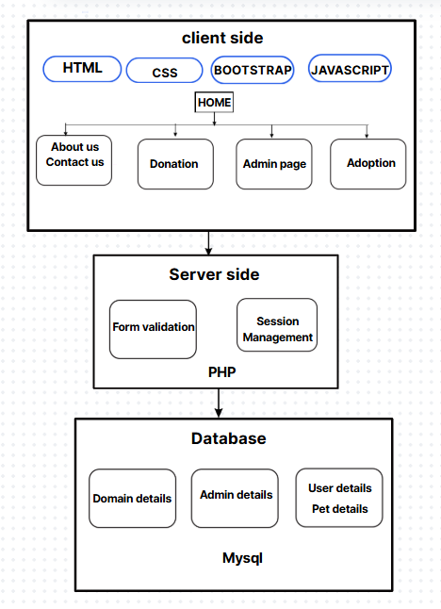

Fig 1 : System Architecture

**5.2 MODULE DESCRIPTION**

**5.2.1 User Management Module**

The User Management Module is a critical component of the pet adoption platform, enabling seamless interaction between users and the system. This module handles all user-related activities, including registration, login, profile management, and access control. By providing a secure and user-friendly interface, the module ensures that users can efficiently manage their accounts and access relevant features of the platform.

**1. Features and Functionalities**

**1.1 User Registration**

* **Purpose:** Allows new users (e.g., adopters, donors, and administrators) to create an account on the platform.
* **Process:**
  + Users fill in mandatory fields such as name, email, and password during registration.
  + Input validation is performed to ensure data accuracy (e.g., valid email format, strong password criteria).
  + The information is securely stored in the MySQL database.

**1.2 User Authentication**

* **Purpose:** Ensures that only authorized users can access the system.
* **Process:**
  + During login, users provide their email and password.
  + The system verifies the credentials by matching them against the database records.
  + Session management is handled using PHP to maintain user login states securely.

**1.3 Profile Management**

* **Purpose:** Allows users to view and update their personal details.
* **Process:**
  + Users can edit their profiles, such as changing their email, name, or password.
  + Password updates are secured by encrypting the new password before storing it in the database.

**1.4 Role-Based Access Control**

* **Purpose:** Restricts or grants access to specific features based on user roles.
* **User Roles:**
  + **Adopters:** Can view pet profiles, initiate adoption requests, and track the adoption process.
  + **Donors:** Can access donation features and view transaction history.
  + **Administrators:** Have full access to manage user accounts, monitor donations, and update pet information.
* This ensures that users only interact with features relevant to their roles.

**2. Database Design for User Management**

The **User** table in the MySQL database underpins the User Management Module. Below are its key attributes:

* **user_id (Primary Key):** A unique identifier for each user.
* **name:** Stores the full name of the user.
* **email:** Contains the user’s email address, which also serves as the username.
* **password:** Stores encrypted passwords for security.
* **role:** Defines the user's role (e.g., adopter, donor, or admin).

**Additional Security Features:**

* Passwords are hashed using encryption algorithms such as bcrypt to ensure they are securely stored.
* Failed login attempts are logged to detect and mitigate potential security breaches.

**3. User Workflow**

**3.1 Registration Workflow**

1. Users navigate to the registration page.
2. They input their details, including name, email, and password.
3. The system validates the input data and stores it in the database.
4. A confirmation email (optional) may be sent to verify the user's email address.

**3.2 Login Workflow**

1. Users enter their email and password on the login page.
2. The system retrieves the corresponding record from the database and validates the password.
3. If authenticated, a session is created, and the user is redirected to their respective dashboard based on their role.

**3.3 Role-Based Dashboard**

* **Adopters:** Dashboard displays available pets, adoption status, and notifications.
* **Donors:** Dashboard provides donation options, history, and updates on shelter activities.
* **Administrators:** Dashboard offers tools to manage users, pets, donations, and system settings.

**4. Security Considerations**

The User Management Module incorporates robust security measures to protect user data and ensure safe system usage:

* **Input Validation:** Prevents malicious input, such as SQL injection or cross-site scripting (XSS) attacks.
* **Password Encryption:** All passwords are encrypted before storage to prevent unauthorized access.
* **Session Management:** Ensures that user sessions are securely maintained and prevents session hijacking.
* **Role-Based Permissions:** Minimizes risks by restricting access to sensitive functionalities.

**5. Benefits of the User Management Module**

**5.1 User-Friendly Interface**

* The module provides an intuitive interface, making it easy for users to register, log in, and manage their accounts.

**5.2 Enhanced Security**

* Robust security features ensure that user data is protected from unauthorized access.

**5.3 Seamless Role Management**

* By categorizing users into distinct roles, the system ensures that users interact with functionalities relevant to their needs.

**5.4 Scalability**

* The module is designed to handle a growing user base, ensuring that performance and usability are not compromised as the system scales.

**5.2.2 Pet Management Module**

The Pet Management Module is one of the core components of the pet adoption platform. It serves as the central hub for managing information related to pets available for adoption. This module provides users with an organized and comprehensive view of all pets, including their species, breed, and adoption status. By integrating various technologies and functionalities, the module ensures a seamless user experience for individuals interested in adopting pets.

**Description**

The Pet Management Module facilitates the management and display of all information related to pets available for adoption. Users can browse the pet catalog, filter pets based on specific attributes such as species or breed, and view the adoption status of each pet. This module bridges the gap between potential adopters and the shelter, enabling adopters to make informed decisions based on the provided details.

**Technologies Used**

To ensure efficiency and scalability, the module is built using the following technologies:

* **PHP:** Used for backend operations such as fetching pet data from the database and updating the adoption status.
* **MySQL:** Serves as the database system for storing and retrieving pet details.
* **HTML/CSS:** Used for structuring and styling the user interface, providing a clean and intuitive design.

**Database Tables Involved**

The **Pet Management Module** utilizes the **Pet** table in the database, which includes the following attributes:

1. **pet_id (Primary Key):** A unique identifier for each pet in the system.
2. **name:** The name of the pet.
3. **species:** Specifies the type of animal (e.g., dog, cat, rabbit).
4. **breed:** Details the breed of the pet.
5. **adoption_status:** Indicates whether the pet is available for adoption or already adopted.

This table ensures that all necessary details about the pets are stored in a structured and easily accessible format.

**Functionalities**

The Pet Management Module includes the following core functionalities:

1. **View Pets**
   * **Purpose:** Allows users to browse the catalog of pets available for adoption.
   * **Details:** Each pet's name, species, breed, and adoption status are displayed along with a photograph and a brief description.
   * **Implementation:**
     + Data is fetched from the **Pet** table in the MySQL database using PHP.
     + The information is displayed dynamically using HTML and styled with CSS for an attractive layout.
2. **Filter by Species/Breed**
   * **Purpose:** Enables users to narrow down the list of pets based on their preferences, such as a specific species or breed.
   * **Details:** Users can use dropdown menus or search boxes to apply filters, making it easier to find suitable pets.
   * **Implementation:**
     + Filter queries are constructed in PHP and sent to the MySQL database to retrieve relevant records.
     + The results are dynamically displayed on the user interface.
3. **Check Adoption Status**
   * **Purpose:** Allows users to view whether a pet is currently available for adoption.
   * **Details:**
     + Pets marked as "Adopted" are displayed with an "Unavailable" tag, while those marked as "Available" can be pursued for adoption.
   * **Implementation:**
     + The **adoption_status** field in the **Pet** table is checked, and the corresponding tag or button is displayed on the interface.

**User Workflow**

The Pet Management Module ensures a smooth workflow for users, as outlined below:

1. **Viewing Pets**
   * Users navigate to the "View Pets" page from the main navigation menu.
   * The system retrieves all pet records from the database and displays them in an organized layout.
   * Each pet's details are presented along with an image to help users make informed choices.
2. **Filtering and Searching**
   * Users apply filters by selecting options from dropdown menus or entering keywords in a search box.
   * The system dynamically updates the pet list based on the specified criteria.
3. **Adoption Status**
   * Users can easily identify pets that are available for adoption through status tags.
   * If a pet is "Available," a button or link is provided to initiate the adoption process.

**Security Considerations**

The module incorporates several security measures to ensure the integrity and confidentiality of pet data:

1. **Input Validation:** All user inputs, such as search terms and filter selections, are validated to prevent SQL injection and other security vulnerabilities.
2. **Data Integrity:** Adoption status updates are performed securely to ensure that pets are not simultaneously adopted by multiple users.

**Benefits of the Pet Management Module**

The Pet Management Module provides numerous benefits for both users and the system administrators:

1. **Comprehensive Information:** Offers potential adopters detailed information about each pet, helping them make informed decisions.
2. **Enhanced User Experience:** Provides filtering and search functionalities to simplify the process of finding pets.
3. **Streamlined Operations:** Simplifies the process of updating pet details and adoption status for system administrators.
4. **Improved Adoption Rates:** Encourages users to proceed with adoption by providing easy access to pet information and availability.

**5.2.3 ADOPTION MODULE**

**Adoption Module**

The Adoption Module is one of the most critical components of the Pet Adoption Management System. It handles all functionalities related to the discovery, application, processing, and tracking of pet adoptions. It bridges the gap between potential adopters and animal shelters through an efficient, transparent, and user-friendly workflow.

**1. Pet Listing and Discovery**

This submodule displays a list of adoptable pets with filters such as breed, age, gender, size, and vaccination status. Each pet is showcased with images and a detailed profile, including medical history and personality traits, helping users make informed choices.

**2. Adoption Application Form**

Once a user selects a pet, they are directed to an adoption form. This form collects:

* Applicant details (name, contact info, address)
* Previous pet ownership experience
* Reasons for adoption
* Environment the pet will live in

This data is stored securely and used by admins for evaluation.

**3. Adoption History and Records**

A separate section maintains a record of all adoptions. This is useful for:

* Tracking which pet has been adopted
* Monitoring repeat applicants
* Auditing and generating reports for administrative use

**4.User Dashboard**

Users have a personal dashboard where they can:

* View adoption status
* Track past adoptions

**5.2.4 Donation Module**

**Donation Module**

The Donation Module plays a vital role in supporting the operational and welfare needs of animal shelters. It facilitates seamless financial contributions from users who wish to support the shelter’s mission without necessarily adopting a pet. This module ensures transparency, security, and convenience in the donation process.

**1. Donation Interface**

The system provides a clean, user-friendly interface where donors can:

* Enter their full name and contact information
* Specify the amount they wish to donate
* Add an optional message or dedication
* Choose a payment method (e.g., credit/debit card, UPI, online banking)

The interface is designed using responsive Bootstrap CSS for accessibility across devices.

**2. Secure Form Handling**

The module includes input validation and backend sanitization to:

* Prevent SQL injection or script attacks
* Ensure proper formatting (e.g., valid email and non-negative donation amount)
* Handle large donations securely

Data is processed through a secure PHP backend and stored in the database.

**3. Donation Record Management**

All donation entries are logged in a dedicated table (e.g., donations) with fields such as:

* Donor name
* Email address
* Amount donated
* Donation date and time
* Custom message (if any)

Admins can view and export donation data for accounting and transparency.

**4. Acknowledgment and Notification**

After a successful donation:

* Donors receive an on-screen thank-you message
* Optionally, a confirmation email can be triggered
* The system may generate a printable receipt

This increases trust and encourages recurring donations.

**5. Admin Dashboard Integration**

Shelter administrators can:

* View total donations by date range
* Filter donations by donor or amount
* Track trends (e.g., average monthly donations)
* Export data for reports or audits

This integration supports transparency and financial planning.

**6. User Engagement**

To maintain engagement:

* High donors can be listed (with permission) in a “Top Contributors” section
* Optional recurring donation feature can be offered.

**CHAPTER – VI**

**RESULT AND DISCUSSION**

**6.1 Results and Discussion**

The pet adoption platform successfully fulfills its objectives of improving the adoption process, enhancing user engagement, and supporting shelters in managing their operations. A user-friendly interface built using HTML, CSS, and JavaScript ensures seamless navigation, while the PHP-based backend guarantees secure session management and efficient data processing. The MySQL database effectively stores and retrieves essential information, including user details, pet profiles, adoption statuses, and donation records.

Key functionalities include the User Management Module, which handles secure registration, login, and role-based access, and the Pet Management Module, which allows users to browse, filter, and view detailed pet profiles. Adoption and donation modules simplify the processes of initiating adoption requests and contributing financially to shelters. These features enhance the user experience, offering transparency through real-time updates on pet availability and adoption requests.

The platform significantly benefits shelters by streamlining operations, automating pet listings, and providing centralized data storage for easier management. However, challenges such as internet reliance and the need for user education remain. Future enhancements, including a mobile application, social media integration, and AI-powered pet recommendations, will further improve accessibility and user engagement.

In conclusion, the platform bridges the gap between adopters and shelters, creating a scalable, transparent, and efficient solution for pet adoption. By addressing the needs of both users and shelters, the system lays a strong foundation for future growth and impact.

# **CHAPTER VII**

**CONCLUSION AND FUTURE ENHANCEMENT**

**7.1 Conclusion**

The Pet Adoption Management System offers a structured and efficient platform for managing pet adoption processes, enabling shelters to maintain organized records, showcase adoptable pets, receive donations, and interact seamlessly with prospective adopters. By incorporating modules such as user registration, pet listing, donation handling, and admin management, the system addresses many of the manual challenges previously faced by adoption centers. This digitization not only streamlines operations but also enhances user engagement and transparency, fostering trust and encouraging more people to adopt pets responsibly. Furthermore, the donation module empowers animal lovers to contribute financially, supporting the shelter's mission sustainably.

**7.2 Future Works**

Looking ahead, there is significant scope for future enhancements. Features such as integration with mobile applications can make the system more accessible on-the-go. Adding AI-based recommendations could suggest pets to users based on their lifestyle and preferences. Real-time chat support with veterinarians or adoption counselors, social media integration for pet promotion, and automated reminders for vaccination or health check-ups can further enrich the platform. Additionally, incorporating blockchain for secure data handling and donation transparency could elevate trust among donors. These improvements will continue to evolve the system into a holistic, intelligent, and impactful tool for advancing animal welfare and responsible pet adoption practices in society.

**SAMPLE CODE**

**A1.Index.php**

<!DOCTYPE html>

<html lang="en">

<head>

  <meta charset="UTF-8">

  <title>Pet Adoption Home</title>

  <meta name="viewport" content="width=device-width, initial-scale=1">

  <!-- Bootstrap CSS CDN -->

  <link href="https://cdn.jsdelivr.net/npm/bootstrap@5.3.0/dist/css/bootstrap.min.css" rel="stylesheet">

  <link href="https://cdnjs.cloudflare.com/ajax/libs/aos/2.3.4/aos.css" rel="stylesheet">

  <style>

    body {

      background-color: #fff0f5;

      font-family: 'Segoe UI', sans-serif;

    }

    .navbar {

      background: linear-gradient(to right, #ff7eb9, #ff65a3);

      position: sticky;

      top: 0;

      z-index: 1000;

      transition: background-color 0.3s ease;

    }

    .navbar:hover {

      background: linear-gradient(to right, #ff65a3, #ff7eb9);

    }

    .navbar-brand, .nav-link {

      transition: color 0.3s ease;

    }

    .navbar-brand:hover, .nav-link:hover {

      color: #fff;

    }

    .guidelines-section {

      padding: 60px 0;

    }

    .section-title {

      color: #d63384;

      font-weight: bold;

      text-align: center;

      margin-bottom: 10px;

      text-transform: uppercase;

    }

    .sub-title {

      text-align: center;

      font-size: 1.1rem;

      margin-bottom: 40px;

      color: #6c757d;

    }

    .guideline-box {

      background-color: #ffe4ec;

      padding: 30px;

      border-radius: 10px;

      margin-bottom: 20px;

      box-shadow: 0 4px 12px rgba(0, 0, 0, 0.08);

      transition: all 0.3s ease;

    }

    .guideline-box:hover {

      transform: scale(1.05);

      box-shadow: 0 8px 20px rgba(0, 0, 0, 0.2);

    }

    .guideline-box h5 {

      color: #e83e8c;

    }

    .img-container {

      text-align: center;

      margin: 30px 0;

    }

    .img-container img {

      width: 45%;

      border-radius: 10px;

      box-shadow: 0 4px 12px rgba(0, 0, 0, 0.1);

      margin: 10px;

      transition: transform 0.3s ease;

    }

    .img-container img:hover {

      transform: scale(1.05);

    }

    /* Call to action button */

    .cta-button {

      background-color: #e83e8c;

      color: white;

      padding: 15px 30px;

      border-radius: 30px;

      font-size: 1.2rem;

      transition: background-color 0.3s ease;

    }

    .cta-button:hover {

      background-color: #d63384;

    }

    /* Add a smooth scroll effect */

    html {

      scroll-behavior: smooth;

    }

    .testimonial-card {

      background-color: #ffebf5;

      padding: 30px;

      border-radius: 10px;

      box-shadow: 0 4px 12px rgba(0, 0, 0, 0.1);

      transition: transform 0.3s ease;

    }

    .testimonial-card:hover {

      transform: scale(1.05);

    }

    .testimonial-card img {

      width: 80px;

      height: 80px;

      border-radius: 50%;

      margin-bottom: 20px;

    }

    .testimonial-section {

      background-color: #ffe4ec;

      padding: 60px 0;

    }

  </style>

</head>

<body>

<!-- Navbar Start -->

<nav class="navbar navbar-expand-lg navbar-dark">

  <div class="container-fluid">

    <a class="navbar-brand" href="index.php">PetAdopt</a>

    <button class="navbar-toggler" type="button" data-bs-toggle="collapse" data-bs-target="#navbarContent">

      <span class="navbar-toggler-icon"></span>

    </button>

    <div class="collapse navbar-collapse" id="navbarContent">

      <ul class="navbar-nav ms-auto mb-2 mb-lg-0">

        <li class="nav-item">

          <a class="nav-link" href="about.php">About Us</a>

        </li>

        <li class="nav-item">

          <a class="nav-link" href="contact.php">Contact Us</a>

        </li>

        <li class="nav-item">

          <a class="nav-link" href="donation/donate.php">Donation</a>

        </li>

        <li class="nav-item">

          <a class="nav-link" href="admin/login.php">Admin Page</a>

        </li>

        <!-- Dropdown for Adoption -->

        <li class="nav-item dropdown">

          <a class="nav-link dropdown-toggle" href="#" id="adoptionDropdown" role="button" data-bs-toggle="dropdown">

            Adoption

          </a>

          <ul class="dropdown-menu" aria-labelledby="adoptionDropdown">

            <li><a class="dropdown-item" href="adoption/guidelines.php">Guidelines</a></li>

            <li><a class="dropdown-item" href="adoption/adoption_form.php">Adoption Form</a></li>

            <li><a class="dropdown-item" href="adoption/pet_details.php">View Pet</a></li>

            <li><a href="adoption/pet_form.php" class="btn btn-pink">Pet Details Form</a>

            </li>

          </ul>

        </li>

      </ul>

    </div>

  </div>

</nav>

<!-- Navbar End -->

<!-- Home Content -->

<div class="container mt-5" data-aos="fade-up" data-aos-duration="1500">

  <h1 class="text-center text-uppercase" style="color: #d63384;">Welcome to Pet Adoption Platform</h1>

  <p class="text-center text-muted">Adopt. Rescue. Love. Give a home to a furry friend!</p>

  <!-- Image Section -->

  <div class="img-container" data-aos="fade-up" data-aos-duration="1500">

    <img src="https://t4.ftcdn.net/jpg/06/10/13/27/360_F_610132710_9M0fM6ggD6Z38yfNdPWQ9w3j6uCOZ54y.jpg" alt="Adopt Your Pet">

    <img src="https://t3.ftcdn.net/jpg/00/55/11/02/360_F_55110240_6ziDUe8c0NDmBsDBae7692ozuzfOJWHG.jpg" alt="Find a Furry Friend">

  </div>

  <!-- Guidelines Section -->

  <div class="guidelines-section" data-aos="fade-up" data-aos-duration="1500">

    <h2 class="section-title">Adoption Guidelines</h2>

    <p class="sub-title">Everything you need to know before adopting a pet</p>

    <div class="guideline-box">

      <h5>Step 1: Choose a Pet</h5>

      <p>Browse our pet catalog and choose a pet that fits your lifestyle and preferences.</p>

    </div>

    <div class="guideline-box">

      <h5>Step 2: Fill Out Adoption Form</h5>

      <p>Complete the adoption form to provide us with details about your home and living situation.</p>

    </div>

    <div class="guideline-box">

      <h5>Step 3: Meet Your New Pet</h5>

      <p>Once your application is reviewed, you’ll be invited to meet your new furry friend and finalize the adoption.</p>

    </div>

  </div>

  <!-- Call to Action Section -->

  <div class="text-center mt-5">

    <a href="donation/donate.php" class="cta-button">Make a Donation Today</a>

  </div>

</div>

<!-- Testimonial Section -->

<div class="testimonial-section">

  <div class="container">

    <h2 class="section-title" data-aos="fade-up" data-aos-duration="1500">What Our Happy Adopters Say</h2>

    <p class="sub-title" data-aos="fade-up" data-aos-duration="1500">Our adopters share their amazing experiences</p>

    <div class="row">

      <div class="col-md-4" data-aos="fade-up" data-aos-duration="1500">

        <div class="testimonial-card">

          <img src="https://static.vecteezy.com/system/resources/previews/000/439/863/non_2x/vector-users-icon.jpg" alt="User 1">

          <h5>John Doe</h5>

          <p>"Adopting a pet from PetAdopt was one of the best decisions I've ever made. My new furry friend is a joy!"</p>

        </div>

      </div>

      <div class="col-md-4" data-aos="fade-up" data-aos-duration="1500">

        <div class="testimonial-card">

          <img src="https://cdn-icons-png.flaticon.com/512/219/219970.png" alt="User 2">

          <h5>Jane Smith</h5>

          <p>"The adoption process was smooth, and I found the perfect companion. Highly recommend this platform!"</p>

        </div>

      </div>

      <div class="col-md-4" data-aos="fade-up" data-aos-duration="1500">

        <div class="testimonial-card">

          <img src="https://png.pngtree.com/png-vector/20221203/ourmid/pngtree-cartoon-style-female-user-profile-icon-vector-illustraton-png-image_6489286.png" alt="User 3">

          <h5>Mark Lee</h5>

          <p>"PetAdopt not only helped me find a pet but also educated me on how to care for them. Great service!"</p>

        </div>

      </div>

    </div>

  </div>

</div>

<!-- Bootstrap JS CDN (includes Popper.js) -->

<script src="https://cdn.jsdelivr.net/npm/bootstrap@5.3.0/dist/js/bootstrap.bundle.min.js"></script>

<script src="https://cdnjs.cloudflare.com/ajax/libs/aos/2.3.4/aos.js"></script>

<script>

  AOS.init();

</script>

</body>

</html>

**OUTPUT:**

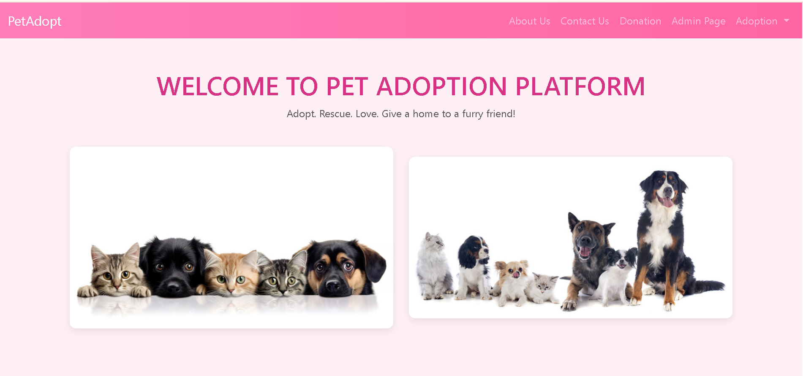

Fig 2 Home page 1

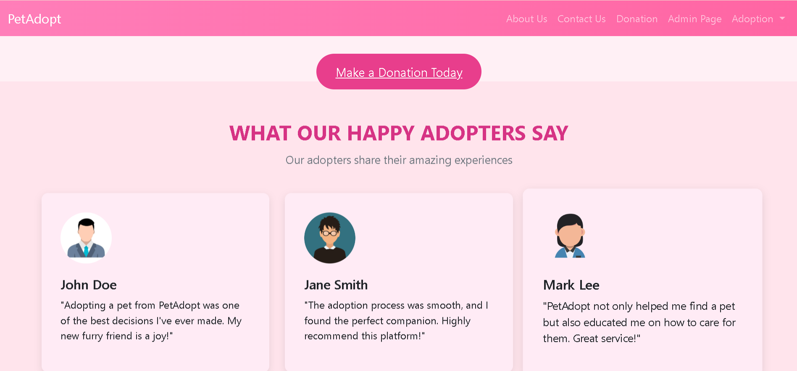

Fig 3 Home Page 2

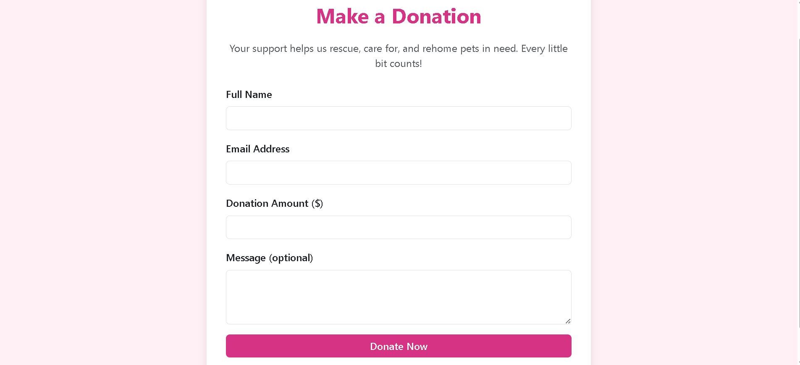

Fig 4 Donation page

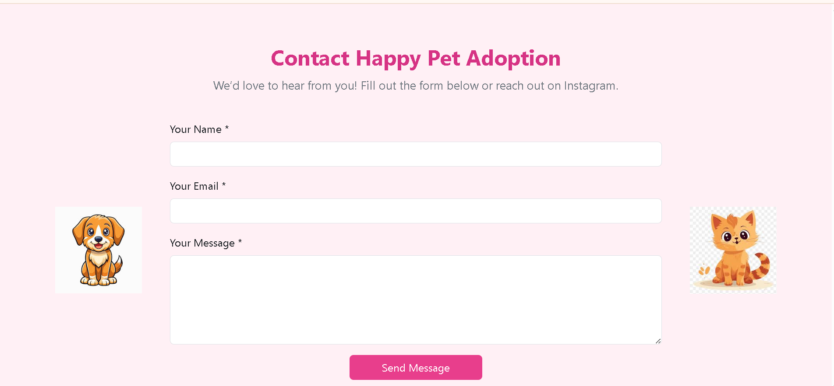

Fig 5 Adoption Page

**REFERENCES**

[1] Liu Ning.Research on the Development of Library Management System Based on JSP[J].Journal of Science of Teachers’ College and University,2017,37(04):22-25.

[2] Wang Dongfang.Research on Online Shopping System Based on JSP[J].Wireless Interconnect Technology,2016(13):54-55+66.

[3] Sun Hongli.Design and Implementation of Student Information Management System Based on JSP[J]. Intelligent Computer and Applications,2017,7(02):108-109+112.

[4] Liu Chunxia.Design of SME Portal Based on JSP[J]. Software Guide,2015,14(06):116-117.

[5] Dong Ting.Design and Implementation of JSP Online Book Purchasing System[J]. Electronic Design Engineering,2014,22(03):11-13.

[6] Educational Resource Management System Based on JSPTechnology[J].EDUCATIONAL SCIENCES-THEORY & PRACTICE,2018. No.6, Vol.18: 3645-3651.

[7] JSP technology to create electronic textbooks, Bulletin of Kazakh National Technical University, 2016. No.2: 486-488

[8] S. K. Singh and R. K. Sharma, "Pet Adoption System Using Machine Learning," *International Journal of Computer Applications*, vol. 182, no. 43, pp. 1–5, 2019.

[9] P. K. Sahu and S. K. Sahu, "Design and Implementation of Pet Adoption System," *International Journal of Advanced Research in Computer Science*, vol. 9, no. 3, pp. 1–5, 2018.

[10] A. K. Saha, S. K. Saha, and M. S. Islam, "A Web-Based Pet Adoption System," in *Proc. 2018 International Conference on Computer, Communication, Chemical, Materials and Electronic Engineering (IC4ME2)*, Rajshahi, Bangladesh, 2018, pp. 1–4.